Agency Address: Inn From The Storm
7584 Olive Blvd., Ste 202
University City, MO 63130
Telephone number: 314-328-9INN (9466)
Email address: nfromthestormlllc@gmail.com

Sandi Colquitt
Sandi Colquitt is the Founder and CEO of Inn From the Storm, a community driven, non-profit organization dedicated to assisting underserved women returning home from prison in the community. Sandi was raised in St. Louis Missouri, attended elementary and high school in the area and participated in community programs throughout the city. Sandi’s parents raised her and her siblings to understand that education was very important in life and taught to be powerful in the community if you wanted to see change. Sandi
is a highly experience … and elected government official with over 25 years of experience.

Sandi obtained her undergraduate degree in Business Administration from Fontbonne University and completed her Master of Health and Public Administration from Webster University. In addition to operating Inn From The Storm, she also works an Organizational Effectiveness Officer for one of largest employers in the State of Missouri. Active participant in multiple community service organizations, holds a State and Local political office, and a member of a professional organization throughout the St. Louis Metropolitan Area.
After years of working with male and females returning home from prison infected and affected with HIV/AIDS, caring for ailing family members, contemplation and having the goal of launching a nonprofit organization benefiting her community, Inn From The Storm was founded in 2016. In September 2016, the organization became a fully formed 501(c)3 with great support from her community, children, and friend
Sandi has a heart for seeing women thrive and is blessed to be a part of Inn From the Storm.

Mission Statement – Inn From is a faith-based non profit organization committed to empowering previously incarcerated women returning home from prison through education, employment, and supported services.

Motto - Come Inn From The Storm and leave with a Blessing

Board of Directors
Derrick Colquitt
Aja Brown
Delores Grady
Cina Winfrey
Denise Smith
Andre Cofer
Attorney Danelle Carter
Honorary Board member – Attorney Thomas Applewhite
Mission statement:

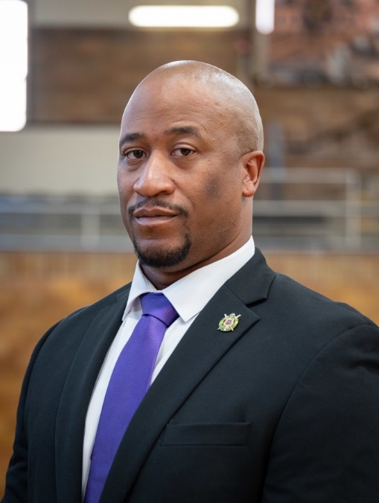

Derrick Colquitt
Programs
Inn from the Storm offers a 3-6 month transitional discharge plan prior to leaving prison. Once released the offenders will be offered 4 creative Transitional Case Management Service Plans designed for ex-offenders based on a comprehensive individual assessment. The programs are designed to mitigate problems for ex-offenders to concentrate on while adjusting to life on the outside. The offenders will become familiar with an organization that will assist with supportive services that will afford a greater chance for success into the community. Inn from the Storm will offer employment services, community service, educational training (assisting with obtaining their GED) mental health counseling, health assessment, and transitional housing.

Therapy
Our in-house therapist is available to ensure each returning citizen a personalized care plan. The ex-offenders need guidance and directions, and this is a top priority. A motivated person will receive the much needed help if they are willing to work for it.

Why We Do This
In the many years of working with individuals, providing supportive services, we recognized a pattern. One, no jobs for the returning citizen with a record. Two, women are more likely to have been the primary caretakers of children prior to entering prison and are more likely to return to that role once released. Women incarceration has caused a significant disruption in their children and family lives. They are constantly worrying about the welfare of their children during their incarceration. Incarcerated women stand to lose their parental rights if they do not stay abreast of child welfare actions that require regular contact between a parent and a child placed in foster care. Third, but not last, If the woman can’t get a job, they can’t pay their fines, pay rent, child support, transportation or even get a birth certificate or state ID. Without a means of support, many will be re-incarcerated and the cycle begins again.
Why Women
The population of women offenders is growing & continues to grow at a faster rate than the population of men. Many feel that the increase to changes in state and national drug policies that mandated prison terms for even relatively low-level drug offenses. According to the Statistics on Women Offenders—2015, the female jail population has been the fastest growing correctional population increasing by an average annual rate of 3.4 percent This does not include women under community supervision.
Women become involved in criminal behavior for different reasons than men:
• Survival of abuse
• Poverty
• Substance abuse
These reasons need to be considered when trying to keep women from reentering the penal system once released.
The relationship between the following three factors are significant and are very common in the life histories of women offenders.
• Physical
• Sexual, and
• Emotional abuse

